 CSE-326 INTERNET PROGRAMMING LABORATORY

BLOOD-DONATION

# GROUP MEMBERS ROLL-NO REGISTRATION-NO

## \* 1 NARENDRA KISHAN 01 11901959

## \* 2 HRISHIKESH DEKA 03 11907303

## \* 3 SIMRAN SINHA 40 11904683

# SECTION- K19PB

# SUBMITTED TO- MISS SHABNAM

INTRODUCTION

## BLOOD-DONATION

A blood donation occurs when a person voluntarily has blood drawn and used for transfusions and/or made into biopharmaceutical medications by a process called fractionation (separation of whole-blood components). Donation may be of whole blood, or of specific components directly (the latter called apheresis). Blood banks often participate in the collection process as well as the procedures that follow it.

Today in the developed world, most blood donors are unpaid volunteers who donate blood for a community supply. In some countries, established supplies are limited and donors usually give blood when family or friends need a transfusion (directed donation). Many donors donate as an act of charity, but in countries that allow paid donation some donors are paid, and in some cases there are incentives other than money such as paid time off from work. Donors can also have blood drawn for their own future use (autologous donation). Donating is relatively safe, but some donors have bruising where the needle is inserted or may feel faint.

Potential donors are evaluated for anything that might make their blood unsafe to use. The screening includes testing for diseases that can be transmitted by a blood transfusion, including HIV and viral hepatitis. The donor must also answer questions about medical history and take a short physical examination to make sure the donation is not hazardous to his or her health. How often a donor can donate varies from days to months based on what component they donate and the laws of the country where the donation takes place.

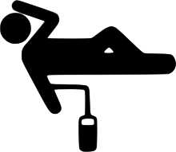

BLOOD DONATION PICTOGRAM

# Website-designing

HTML- It provides a means to create structured documents by

Denoting structural semantics for text such as headings,

Paragraphs,lists,link,quotes and other items

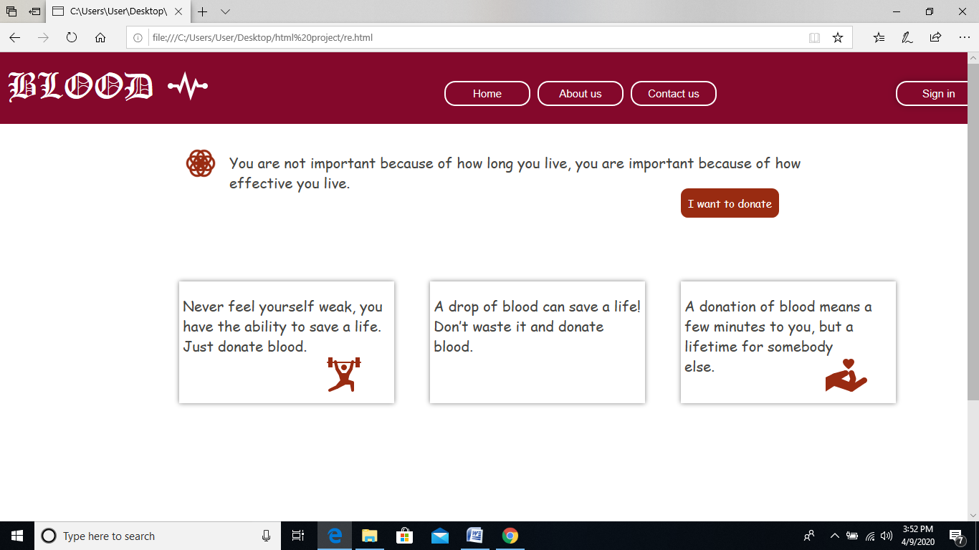

(PRESENTED BY-SIMRAN SINHA)

## Different HTML tags used in Designing-

|  |  |  |  |
| --- | --- | --- | --- |
| SERIAL NO | OPENING TAG | CLOSING TAG | STRUCTURE SPECIFIED |
| 1 | <p> | </P> | Pragraph text |
| 2 | <h1> | </h1> | Main heading |
| 3 | <h2> | </h2> | Sub heading |
| 4 | <a> | </a> | Anchor tag |
| 5 | <a herf=”url”> | </a> | Hyperlink |
| 6 | <img src=”url”> | None | Image |
| 7 | <input> | </input> | Form input field is used  To create. |
| 8 | <meta> | </meta> | Meta tag |
| 9 | <sub> | </sub> | The subscripted text indicates. |
| 10 | <sup> | </sup> | Superscripted text indicates. |
| 11 | <td> | </td> | Used to make cell |
| 12 | <tr> | </tr> | Table row |
| 13 | <br> | None | Line break |
| 14 | <i> | </i> | Italic text |

CSS- It is style sheet language used for describing the presentation of a document written in html.

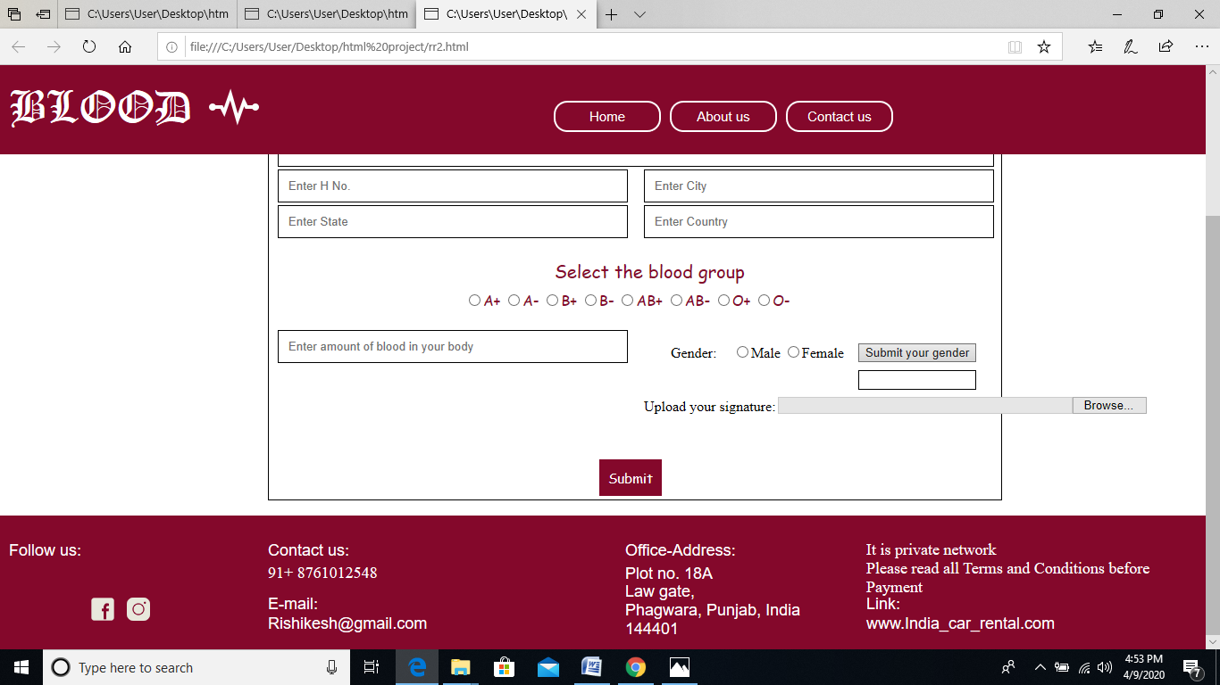

## (PRESENTED BY-HRISHIKESH DEKA)

Shows different colour (white and red) on pressing submit button as shown in the picture above.

## DIFFERENT CSS TAGS USED IN DESIGNING-

|  |  |
| --- | --- |
| PROPERTY | DESCRIPTION |
| 1 Align-content | Specifies the alignment of flexible containers items with Within the flex containers. |
| 2 Background -colour | Define an always background color |
| 3 Background -image | Define an element background image |
| 4 Background -size | Specifies the size of background image |
| 5 Border-image-source | Specifies the location of image where border is used. |
| 6 Font | Defines a variety of font properties within one decleration. |
| 7 Padding-left | Sets the padding to the left side of the element. |
| 8 Padding-right | Sets the padding to the right side of an element. |
| 9 Text-align | Sets the horizontal alignment of inline content. |
| 10 Word-spacing | Set the space between words. |
| 11 Max-height | Specify the maximum height of an element. |
| 12 Font-size | Defines the font size for the text. |
| 13 Height | Specify the height of an element. |
| 14 Left | Specify the location of the left edge of the positioned element. |
| 15 Margin | Sets the margin on all four sides of the element. |
| 16 Vertical-align | Sets the vertical positioning of an element relative  To the current text baseline. |
| 17 Resize | Specifies whether element is resizable or not. |

JAVA-SCRIPT- It is a high level,often in just time compile and multi paradigm bracket syntex dynamic type, prototype based object orientation and first class functions.

(Minimizing the window,shows how this page is responsive)

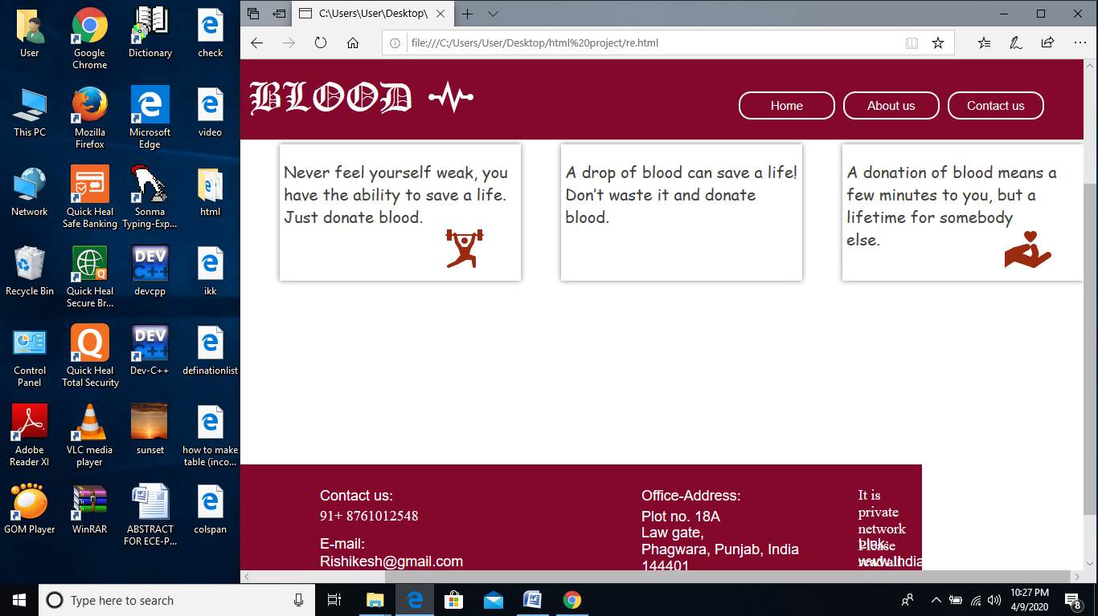

## (PRESENTED BY- NARENDRA KISHAN)

# SYSTEM DESCRIPTION-

\*ABOUT:

In this section user can know all about this website and its working.

\*CONTACT US:

This page provides facility to customer to contact us through mail or by mobile number.

\*SIGN IN:

This will give you acess to log in to e-mail id and password after giving all the necessary details you can easily be able to sign in.

\*I WANT TO DONATE:

After clicking on this button this will ask you whether you are a member or first time donar.and after filling all the necessary details u will be able to donate.

# DIFFERENT TYPES OF LOGO USED:

C:\Users\User\Desktop\html project\gym.png C:\Users\User\Desktop\html project\hand_h.png C:\Users\User\Desktop\html project\see.png  C:\Users\User\Desktop\html project\trust.png

GYM HAND-H SEE SEED TRUST

* C:\Users\User\Desktop\html project\up_hide.png C:\Users\User\Desktop\html project\tw (1).png C:\Users\User\Desktop\html project\insta.png C:\Users\User\Desktop\html project\fb.png

UP-EYE UP-HIDE TWITTER INSTA FB

# CONCLUSION

One thing is clear-donating blood has many benefits to the donar as well as the recipent.so,if you want to pick up a healthy habit,head over to your local blood center and the website created over here and give the gift of life.

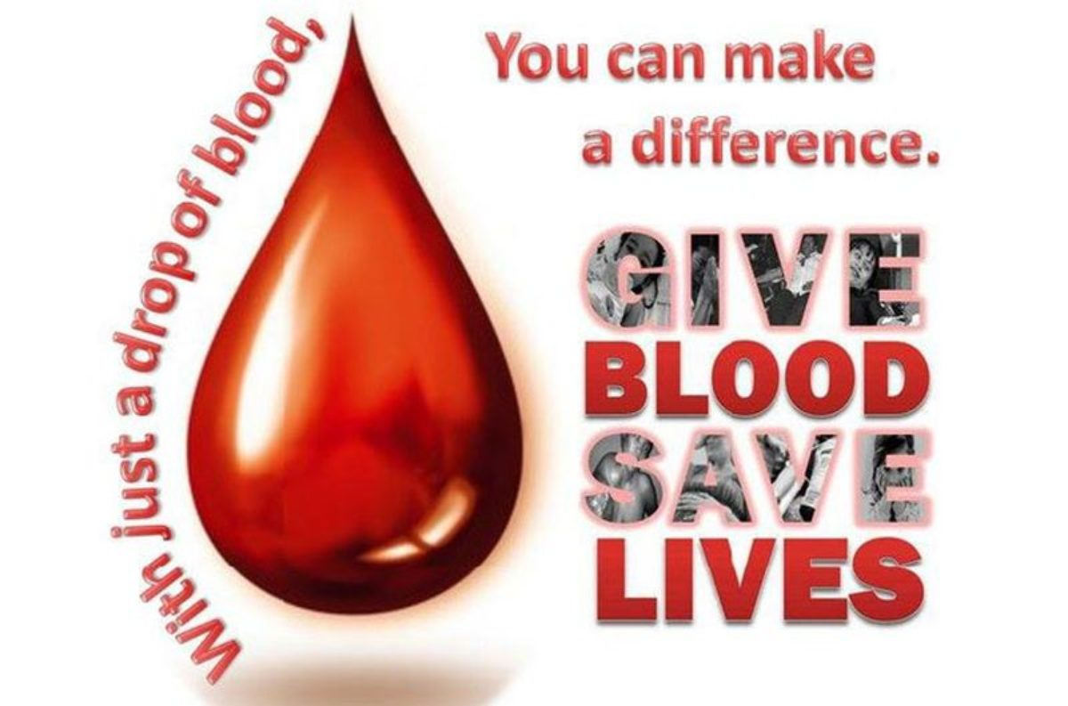

# REFERENCE:-

BOOKS- HTML 5(BLACK BOOK)

WEBSITES- [WWW.W3SCHOOLS.COM](http://WWW.W3SCHOOLS.COM)

THANKYOU….

# 